Experiment 7

**Implementing servlet program and**

**Cookies**

Name: Sai Harsha Vardhan AVN

Roll-no: BCSE1823

Batch: ‘A’

**Aim**: Write servlet program and implement Cookies

**Theory:**

Servlets are Java classes which service HTTP requests and implement the **javax.servlet.Servlet** interface. Web application developers typically write servlets that extend javax.servlet.http.HttpServlet, an abstract class that implements the Servlet interface and is specially designed to handle HTTP requests.

Steps to create a servlet example

There are given 6 steps to create a **servlet example**. These steps are required for all the servers.

The servlet example can be created by three ways:

1. By implementing Servlet interface,
2. By inheriting GenericServlet class, (or)
3. By inheriting HttpServlet class

The mostly used approach is by extending HttpServlet because it provides http request specific method such as doGet(), doPost(), doHead() etc.

There are few server’s to run your application , you can use either of those for example we have **apache tomcat server, Glassfishserver etc**. The steps are as follows:

1. Create a directory structure
2. Create a Servlet
3. Compile the Servlet
4. Create a deployment descriptor
5. Start the server and deploy the project
6. Access the servlet

Directory/File Structure for Servlet Programs to run is shown below:

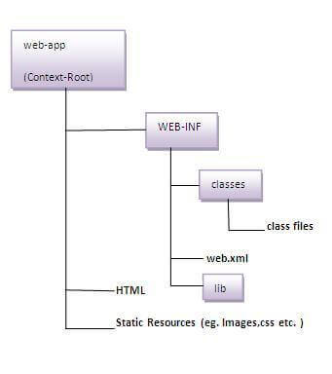

**Cookies**: Cookies are text files stored on the client computer and they are kept for various information tracking purpose. Java Servlets transparently supports HTTP cookies.

A cookie has a name, a single value, and optional attributes such as a comment, path and domain qualifiers, a maximum age, and a version number.

There are 2 types of cookies in servlets.

1. Non-persistent cookie
2. Persistent cookie:

### **Non-persistent cookie**

It is **valid for single session** only. It is removed each time when user closes the browser.

### **Persistent cookie**

It is **valid for multiple session**. It is not removed each time when user closes the browser. It is removed only if user logout or sign-out.

Creation of a cookie syntax:

1. Cookie ck=new Cookie ("user","sai");//creating cookie object
2. response.addCookie(ck);//adding cookie in the response

Deleting a Cookie Syntax:

1. Cookie ck=new Cookie("user","");//deleting value of cookie
2. ck.setMaxAge(0);//changing the maximum age to 0 seconds
3. response.addCookie(ck);//adding cookie in the response

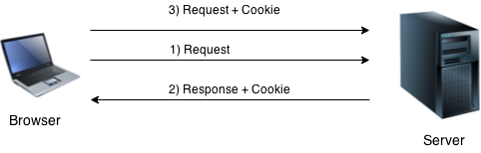

**Code**:

1. ***Web.xml Code***:

<?xml version="1.0" encoding="UTF-8"?>

<web-app version="3.1" xmlns="http://xmlns.jcp.org/xml/ns/javaee" xmlns:xsi="http://www.w3.org/2001/XMLSchema-instance" xsi:schemaLocation="http://xmlns.jcp.org/xml/ns/javaee http://xmlns.jcp.org/xml/ns/javaee/web-app_3_1.xsd">

<servlet>

<servlet-name>HelloForm</servlet-name>

<servlet-class>HelloForm</servlet-class>

</servlet>

<servlet>

<servlet-name>DeleteCookies</servlet-name>

<servlet-class>DeleteCookies</servlet-class>

</servlet>

<servlet>

<servlet-name>ReadCookies</servlet-name>

<servlet-class>ReadCookies</servlet-class>

</servlet>

<servlet>

<servlet-name>SessionTrack</servlet-name>

<servlet-class>SessionTrack</servlet-class>

</servlet>

<servlet-mapping>

<servlet-name>HelloForm</servlet-name>

<url-pattern>/HelloForm</url-pattern>

</servlet-mapping>

<servlet-mapping>

<servlet-name>DeleteCookies</servlet-name>

<url-pattern>/DeleteCookies</url-pattern>

</servlet-mapping>

<servlet-mapping>

<servlet-name>ReadCookies</servlet-name>

<url-pattern>/ReadCookies</url-pattern>

</servlet-mapping>

<servlet-mapping>

<servlet-name>SessionTrack</servlet-name>

<url-pattern>/SessionTrack</url-pattern>

</servlet-mapping>

<session-config>

<session-timeout>

30

</session-timeout>

</session-config>

</web-app>

1. **Index.html Code:**

<!DOCTYPE html>

<html>

<head>

<title>TODO supply a title</title>

<meta charset="UTF-8">

<meta name="viewport" content="width=device-width, initial-scale=1.0">

<style>

body {

background-color: #F3EBF6;

font-family: 'Ubuntu', sans-serif;

}

form.form1 {

padding-top: 40px;

}

.un:focus, .pass:focus {

border: 2px solid rgba(0, 0, 0, 0.18) !important;

}

</head>

<body>

<form action = "HelloForm" method = "GET">

<div class="main">

<p class="sign" align="center">Sign in</p>

<form class="form1">

<input class="un " type="text" align="center" placeholder="username" name="user_name">

<input class="pass" type="password" align="center" placeholder="password" name="password">

<input type="submit" class="submit" value="Sign in">

<p class="forgot" align="center"><a href="#">Forgot Password?</p>

</form>

</div>

</body>

</html>

Top of Form

1. **Cookie Creation Code:**

import java.io.*;

import javax.servlet.*;

import javax.servlet.http.*;

public class HelloForm extends HttpServlet {

public void doGet(HttpServletRequest request, HttpServletResponse response)

throws ServletException, IOException {

Cookie firstName = new Cookie("user", request.getParameter("user_name"));

Cookie lastName = new Cookie("password", request.getParameter("password"));

firstName.setMaxAge(60 * 60 * 24);

lastName.setMaxAge(60 * 60 * 24);

response.addCookie(firstName);

response.addCookie(lastName);

response.setContentType("text/html");

PrintWriter out = response.getWriter();

String title = "Setting Cookies Example";

String docType

= "<!DOCTYPE html>\n";

out.println(docType

+ "<html>\n"+ "<head>"+ " <title>" + title + "</title>" + "</head>\n"

+ "<body bgcolor = \"#f0f0f0\">\n" + "<h1 align = \"center\">" + title + "</h1>\n"

+ "<ul>\n” + " <li><b>User:</b>: "

+ request.getParameter("user_name") + "\n"

+ " <li><b>Password:</b>: "

+ request.getParameter("password") + "\n"

+ "</ul>\n"

+ "</body>"

+ "</html>"

);

}

}

Bottom of Form

1. **Deletion of a cookie Code:**

import java.io.*;

import javax.servlet.*;

import javax.servlet.http.*;

public class DeleteCookies extends HttpServlet {

public void doGet(HttpServletRequest request, HttpServletResponse response)

throws ServletException, IOException {

Cookie cookie = null;

Cookie[] cookies = null;

cookies = request.getCookies();

response.setContentType("text/html");

PrintWriter out = response.getWriter();

String title = "Delete Cookies Example";

String docType

= "<!!DOCTYPE html>\n";

out.println(docType

+ "<html>\n"

+ "<head><title>" + title + "</title></head>\n"

+ "<body bgcolor = \"#f0f0f0\">\n");

if (cookies != null) {

out.println("<h2> Cookies Name and Value</h2>");

for (int i = 0; i < cookies.length; i++) {

cookie = cookies[i];

if ((cookie.getName()).compareTo("first_name") == 0) {

cookie.setMaxAge(0);

response.addCookie(cookie);

out.print("Deleted cookie : " + cookie.getName() + "<br/>");

}

out.print("Name : " + cookie.getName() + ", ");

out.print("Value: " + cookie.getValue() + " <br/>");

}

} else {

out.println("<h2>No cookies founds</h2>");

}

out.println("</body>");

out.println("</html>");

}

}

**Output:**

* 1. **Starting Servlet page:**

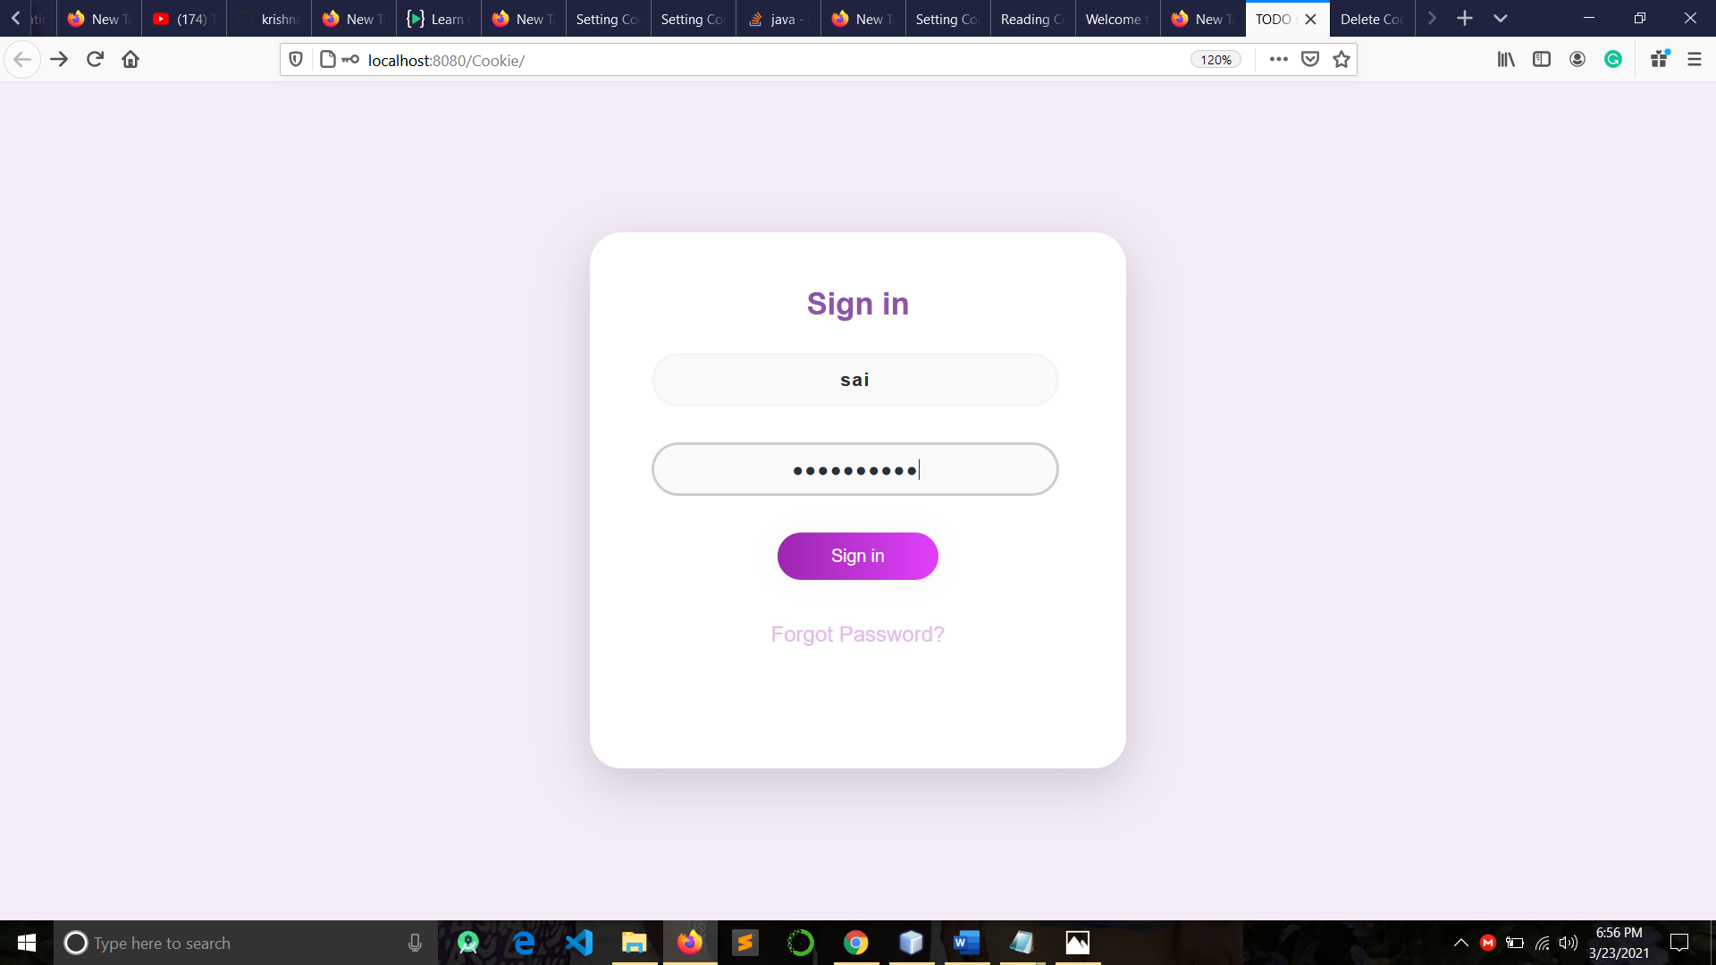

* 1. **Cookie created page:**

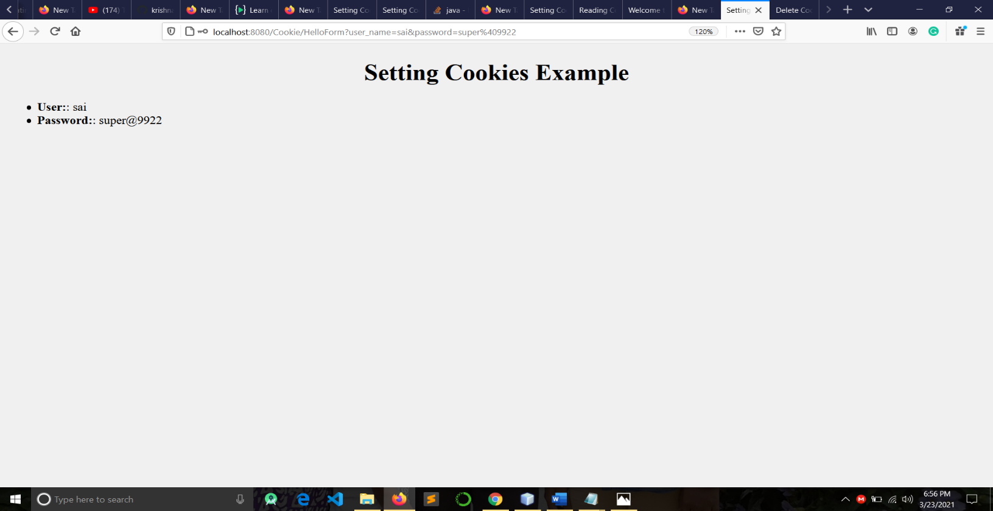

* 1. **Deleted Cookie:**

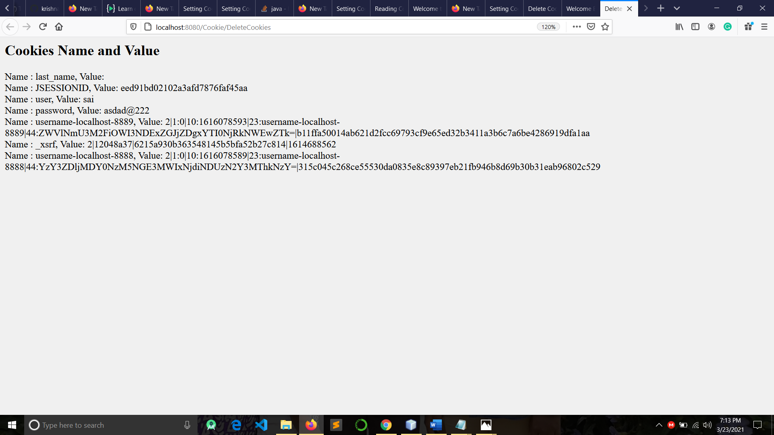

**Conclusion:** Servlet program and Cookies implemented successfully.